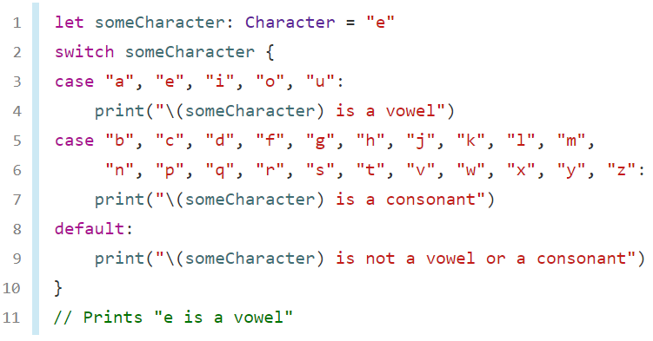

let number = 5

switch number {

case 0..<5:

print("First group")

case 5...10:

print("Second group")

case 0...5:

print("Third group")

default:

print("Fourth group")

}

var someCharacter, yourCharacter:Character

print("Enter a letter:", terminator:"")

let sC = Character(readLine()!)

yourCharacter = sC

someCharacter = Character(String(yourCharacter).lowercased())

// let someCharacter; Character = "e"

switch someCharacter {

case "a", "e", "i", "o", "u":

print("\(someCharacter) is a vowel")

case "b", "c", "d", "f", "g", "h", "j", "k", "l", "m", "n", "p", "q", "r", "s", "t", "v", "w", "x", "y", "z":

print("\(someCharacter) is a consonant")

default:

print("\(someCharacter) is not a vowel or a consonant")

}

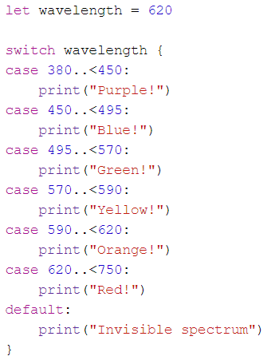

var wavelength: Int

print("Enter a number:", terminator:"")

let wL = Int(readLine()!)

wavelength = wL!

switch wavelength {

case 380..<450: // Between 380 and 449

print("Purple!")

case 450..<495: // between 450 and 494

print("Blue!")

case 495..<570: // Between 495 and 569

print("Green!")

case 570..<590: // Between 570 and 589

print("Yellow!")

case 590..<620: // Between 590 and 619

print("Orange!")

case 620..<750: // Between 620 and 749

print("Red!")

default: // Do if no case is satisfied

print("Invisible spectrum")

}

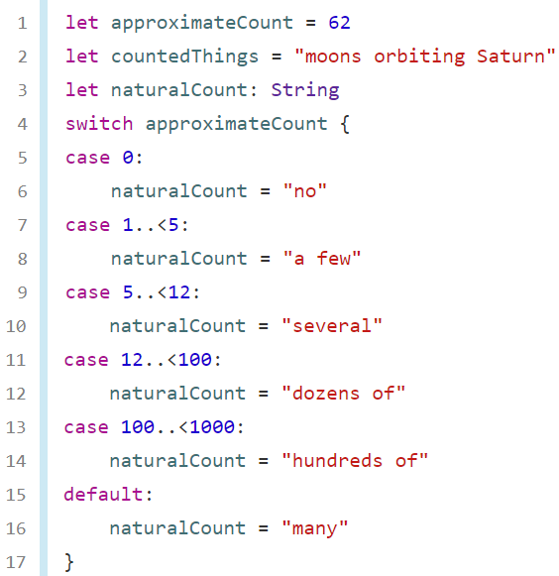

var approximateCount: Int

print("Enter a number:", terminator:"")

let aC = Int(readLine()!)

approximateCount = aC!

let countedThings = "moons orbiting Saturn"

let naturalCount: String

switch approximateCount {

case 0:

naturalCount = "no"

case 1..<5:

naturalCount = "a few"

case 5..<12:

naturalCount = "several"

case 12..<100:

naturalCount = "dozens of"

case 100..<1000:

naturalCount = "hundreds of"

default:

naturalCount = "many"

}

print(naturalCount)

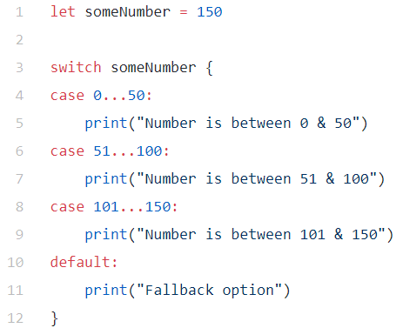

let someNumber = 150

switch someNumber {

case 0...50:

print("Number is between 0 & 50")

case 51...100:

print("Number is between 51 & 100")

case 101...150:

print("Number is between 101 & 150")

default:

print("Fallback option")

}

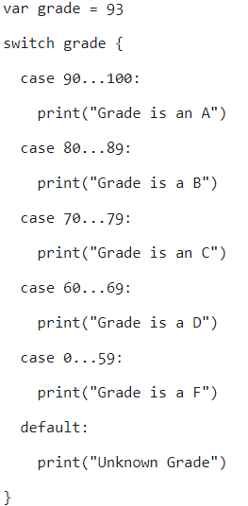

var grade = 93

switch grade {

case 90...100:

print("Grade is an A")

case 80...89:

print("Grade is a B")

case 70...79:

print("Grade is a C")

case 60...69:

print("Grade is a D")

case 0...59:

print("Grade is an F")

default:

print("Unknown Grade")

}

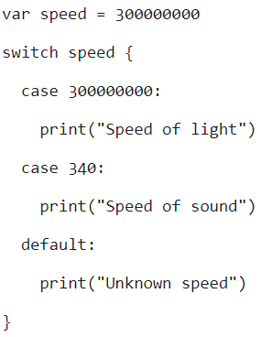

var speed = 300000000

switch speed {

case 300000000:

print("Speed of light")

case 340:

print("Speed of sound")

default:

print("Unknown speed")

}

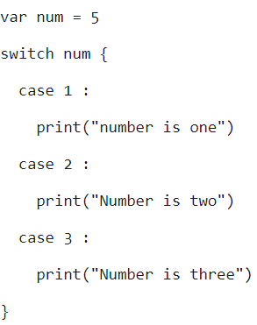

var num = 5

switch num {

case 1:

print("number is one")

case 2:

print("Number is two")

case 3:

print("Number is three")

}

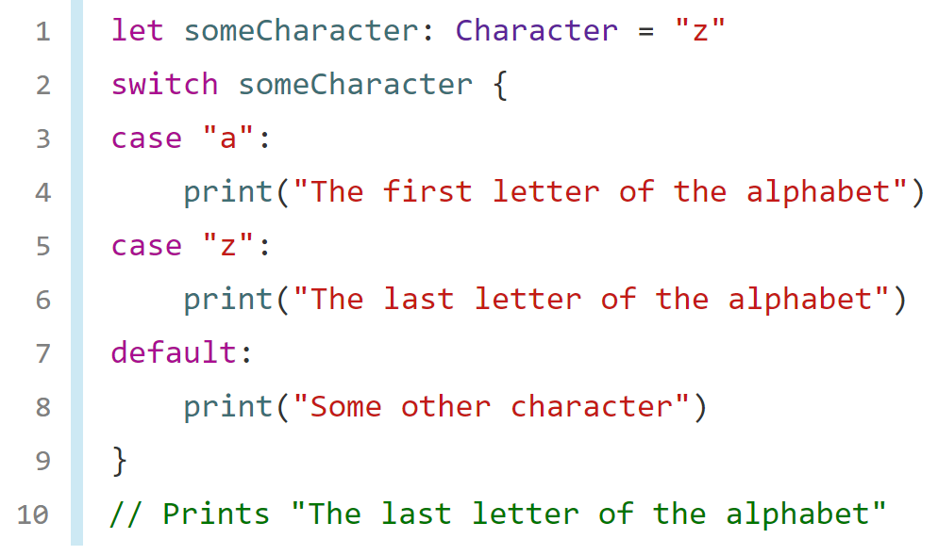

let someCharacter: Character = "g"

switch someCharacter {

// is value in someCharacter == "a"?

case "a":

print("The first letter of the alphabet")

// is value in someCharacter == "z"?

case "z":

print("The last letter of the alphabet")

// do if no case is satisfied

default:

print("Some other character")

}

print("I am after switch statement")

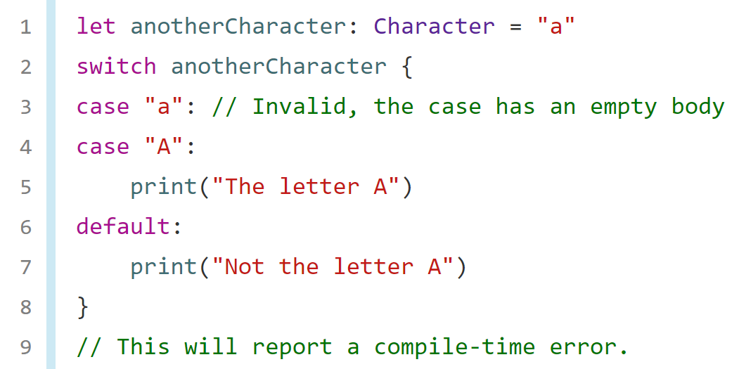

let anotherCharacter: Character = "a"

switch anotherCharacter {

case "a": // Invalid, the case has an empty body

case "A":

print("The letter A")

default:

print("Not the letter A")

}

print("I am after switch statement")

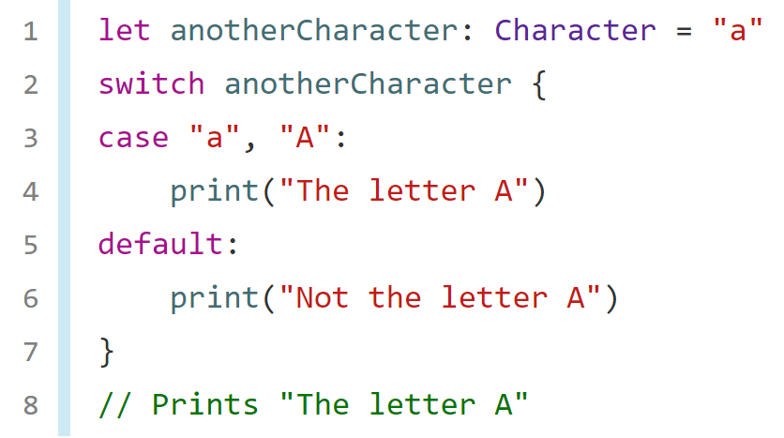

let anotherCharacter: Character = "a"

switch anotherCharacter {

case "a", "A":

print("The letter A")

case "p", "P":

print("The letter P")

case "g", "G":

print("The letter G")

default:

print("Not the letter A")

}

print("I am after switch statement")



//swift 3.0.2

let someCharacter: Character = "a"

switch someCharacter {

case "a":

print("The first letter of the alphabet")

case "z":

print("The last letter of the alphabet")

default:

print("Some other character")

}

print("I am after switch statement")

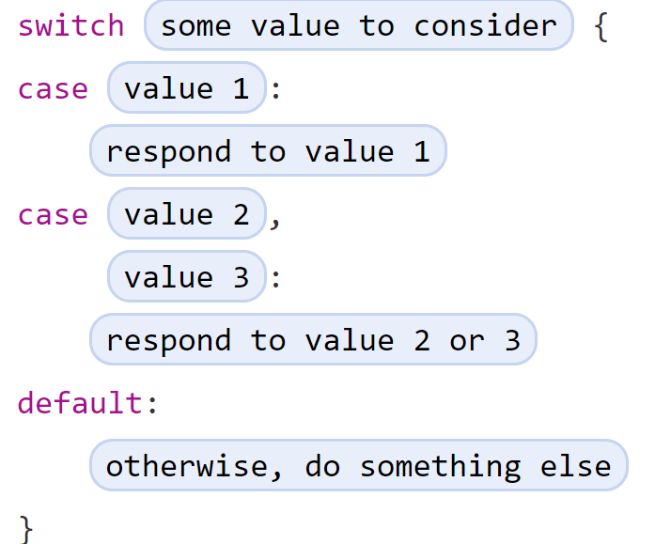

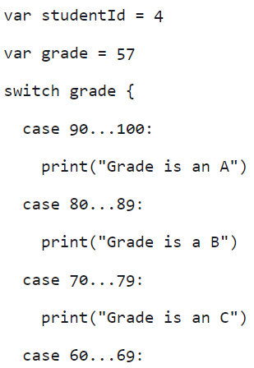

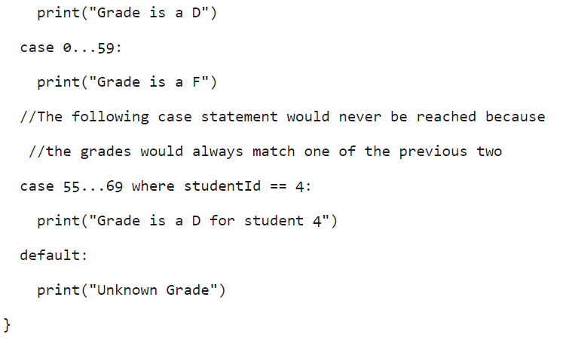

**Swift Compiler with input**

<https://repl.it/languages/swift>